**Screen Layout Charts**

Main Menu

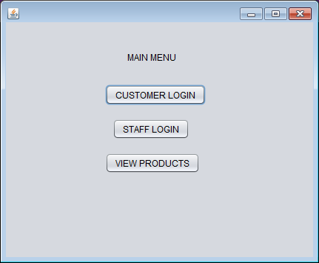

Customer Login

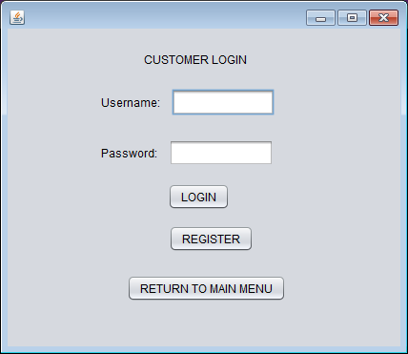

Customer Home

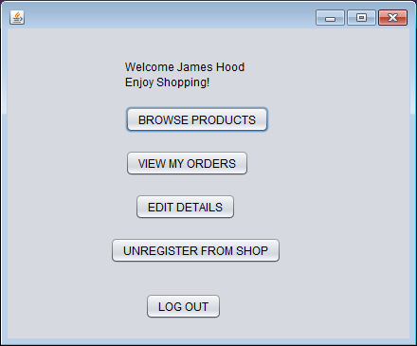

Staff Login

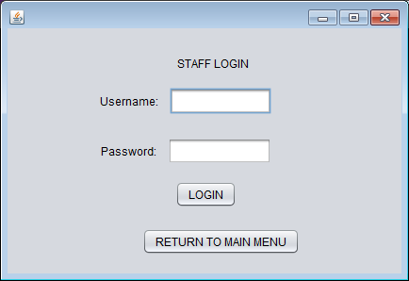

Staff Home

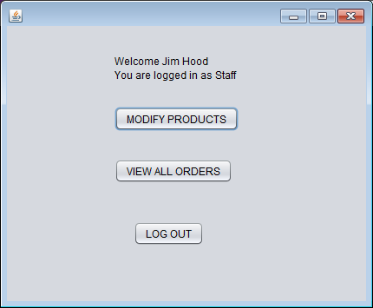

Create new methods inside Customer and Staff class- both called **displayGreeting** which should return the appropriate greeting which is displayed at the top Customer Home / Staff Home.